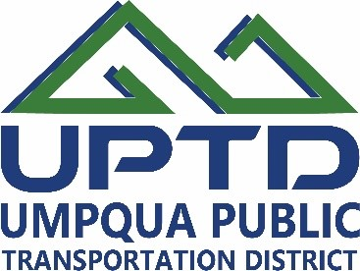

Volunteer Drivers
UPTD is seeking volunteer drivers for medical transportation. This position requires use of your personal vehicle and is paid mileage reimbursement only. Hours and days may vary. Must be able to pass a background check and drug test. Vehicle must be able to pass an ASE inspection. The ideal candidate is a safe driver, dedicated, good with directions and enjoys driving, meeting new people and helping people in need while earning money to cover expenses.

Please submit a volunteer application and we will contact you with more details.

